Curriculum Vitae _ Saad Abdulmajed Salman

Objective .
To participate and have a position of responsibility in the fields of control Engineering (fundamental of control, PID controller, and fuzzy logic controller) that enables me to utilize my skills and theoretical expertise to serve university teaching and working.
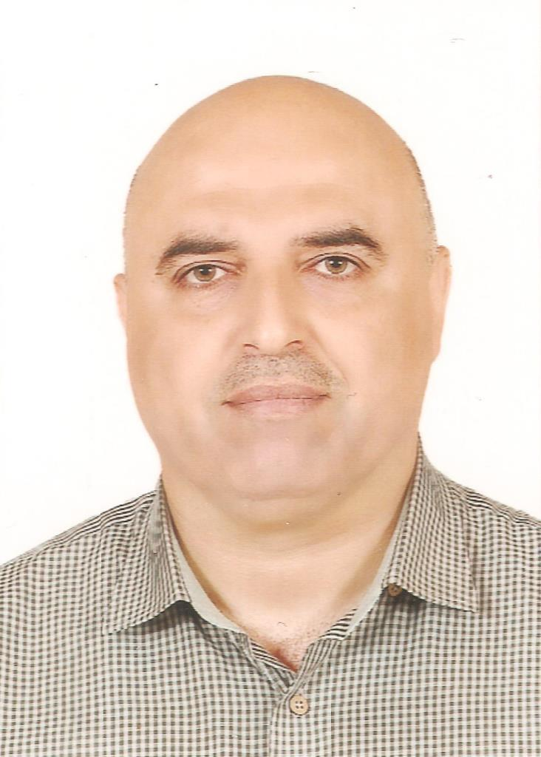
Personal Information .
Academic degree: Lecturer
ORCID : 0000-0001-6540-4338
h – Index: 1 calculated by Google Scholar
Birth Date & Place: July 24, 1969 – Iraq
Nationality: Iraqi
Passport Number: A10610550 valid until July 16, 2024
Marital Status: Married – Three child
Mobile: Iraq\+964 7901767327 \ +9647705391730
Email: drsaad69@gmail.com and drsaad_eng@uodiyala.edu.iq
Website: www.engineering.uodiyala.edu.iq
License: Iraqi International Driving License.
Postal address: Department of Computer Engineering, College of Engineering, Diyala University, Baqubah City, Diyala Governorate, ZIP 964, Iraq.
Professional Strength and Skills .
- Very effective in fundamental of control engineering, especially principles of control engineering, PID controller, and fuzzy logic controller.
- Wide theoretical knowledge in most subject of electrical and electronic engineering such as electrical circuits, electronics, mathematics, and engineering analysis.
Educational Qualifications .
- Ph.D. Electrical and Electronic Engineering 2006 Al-Rashied college of engineering & science – University of Technology - Iraq. (English Curriculum)
- Ms. C. Electrical and Electronic Engineering 1997 Al-Rashied college of engineering & science – University of Technology - Iraq. (English Curriculum).
- B.Sc. Electrical and Electronic Engineering 1992 Al-Rashied college of engineering & science – University of Technology - Iraq. (English Curriculum).
Memberships and Academic positions .
- Head of Computer and Software Engineering Department - College of Engineering – Diyala University since 2004 – 2012.
- Director of the Scientific & Consultant Services Bureau/ Engineering College/ Diyala University since 2009 – 2013.
- Chairman of Examination committee and scientific research committee in department of computer and software engineering, Engineering College, Diyala University since 2004 – 2012.
- Member of Engineering College Board since 2004 – 2012.
- The representative of Diyala University in Arab Council for Training Students of Arab Universities (ACTSAU) since 2010 – 2012.
- Member of Computer Engineering Department Board since 2012 till now.
- Chairman of Quality assurance and university performance committee in department of computer and software engineering, Engineering College, Diyala University since 2014 – 2016.
- Chairman of Educational guidance committee in department of computer and software engineering, Engineering College, Diyala University since 2016 till now.
- Member of Examination committee of Computer Engineering Department – College of Engineering – Diyala University 2015/2016.
- Member of Scientific Committee of Computer Engineering Department – College of Engineering – Diyala University 2012 till now.
- Member of Iraqi Engineers Union (IEU) since 1993 till now.
Training and Courses .
- Computer Programming Course for one month in Diyala University –Computer and Internet Center – Iraq - 2005.
- Methods of Teaching Course for one month in College of Education– Diyala University – Iraq - 2005.
- Test the safety of the Arabic language in Diyala University – 2011.
- Teaching validity test in Diyala University – 2011.
Languages .
- English: Written and spoken (good)
- Arabic: Mother tongue.
Employment History (Academic & Technical) .
Diyala University – College of Engineering (2004 – till now)
Location: Diyala – Iraq
Position: Head of Computer Engineering Department until 2012 and one of academic staff in same department.
Academic degree: Lecturer
Description: Teaching control and computer control for the third and fourth stages respectively in Computer Engineering Department.

University of Technology – Al-Rashied college of engineering & science (1992 – 2004)
Location: Baghdad – Iraq
Position: lecturer
Description: Teaching the Electrical Systems and Flight Control for the fourth and fifth stages respectively in Electrical and Electronic Engineering Department.
Diyala University – College of Engineering (1998 – 2004)
Location: Diyala – Iraq
Position: External Lecturer.
Description: Teaching Analogue Electronics for the second stage in Electronic and Power Engineering Departments.
Diyala University – College of Basic Education (1998 – 2000)
Location: Diyala – Iraq
Position: External Lecturer.
Description: Teaching Numerical Analysis and Complex Numbers for the fourth stage in Mathematic Department.
Technical Institute of Baqubah (1997 – 2000)
Location: Diyala – Iraq
Position: External Lecturer.
Description: Teaching Basics of Electrical Engineering for the first stage in Electrical Department.

Supervision of Theses and dissertations `
- Supervising the graduation projects of the fourth stage in the Department of Computer Engineering, College of Engineering, Diyala University, Iraq.

Reviewer and referee
Reviewer and referee in:
- Diyala Journal of Engineering Sciences - College of Engineering - Diyala University.

Awards and Prizes
- The 14th Student Forum with a certificate of appreciation for supervising student graduation research, which was established by the Arab Council for Training Students of Arab Universities (ACTSAU) and Alexandria University. – 2011.
- Certificate of appreciation from the Arab Council for Training Students of Arab Universities (ACTSAU) in order to participate in the 16th Forum for the exchange of offers of training for students of Arab universities held at the University of Jordan in 2010.
- A certificate of appreciation from the Arab Council for Training Students of Arab Universities (ACTSAU) to participate in the 17th Forum for the exchange of offers of training for students of Arab universities held at Al-Hussein Bin Talal University in 2011.
- The first rank in the evaluation of the performance of staff academics (lecturer) at the level of the country's universities for the academic year 2009/2010.

Published Research Papers .
No | Title of research | Journal name | Publisher or hosting | ISSN
1 | analysis and performance evaluation of the position control of an AC motor using PD-PIPID fuzzy logic controller | British journal of mathematics and computer science. Vol.: 4, Issue.: 6 (16-31 March) 2013 | SCIENCEDOMAIN international | 2231-0851
2 | Design of PSO-Based Optimal/Tunable PID Fuzzy Logic Controller Using FPGA | publication in the book "Matlab / Book 1", ISBN 978-953-308-94-9 | INTECH Science, Technology and Medicine open access publisher | ISBN 978-953-307-907-3
3 | Design an Adjustable Narrow Correlator to Track GPS Signals | Periodica Polytechnica Electrical Engineering and Computer Science, 2019 | Periodica Polytechnica Office  Published online: 09 July 2019  https://doi.org/10.3311/PPee.13570 | Online ISSN: 2064-5279  Print ISSN: 2064-5260
4 | Stability and performance evaluation of the speed control of DC motor using state-feedback controller | Indonesian Journal of Electrical Engineering and Computer Science Vol. 22, No. 3, June 2021, pp. 1372~1378 | Institute of Advanced Engineering and Science (IAES)  http://doi.org/10.11591/ijeecs.v22.i3.pp1372-1378 | 2502-4752

Conferences .
No | Conference | Type of activity | Notes
1 | First Scientific Conference in Engineering Sciences, Diyala University, College of Engineering, Dec. 22-23, 2010. Iraq. | Member of the Preparatory Committee for the Conference
2 | Second Scientific Conference in Engineering Sciences, Diyala University, College of Engineering, Dec. 16-17, 2015. Iraq. | Chairman of the Third Scientific Session of the Second Scientific Conference, the third axis (computer and software engineering)

For more information visit the following links of Social and Scientific media
Research Gate | https://www.researchgate.net/profile/Saad_Salman7
Acadimeca.edu | https://uodiyala.academia.edu/DrSaadSalman
Google Scholar | https://scholar.google.com/citations?user=8LWPYiUAAAAJ
  Publons  | https://publons.com/author/1219586/dr-saad-a-salman#profile
ORCID http://orcid.org/0000-0001-6540-4338
Facebook | https://www.facebook.com/saad.alqaisy
Twitter | https://twitter.com/drsaadalqaisy

